LOAN AGREEMENT

The undersigned:

iMAL
30 – 34, Quai Des Charbonnages / Koolmijnenkaai 1080 Brussels
Represented by Lucia Garcia, director
Hereafter called ‘the Organizer’;
and

Manoah Camporini
15 avenue Enest-Pictet, 1203 Geneve (Switzerland)
Represented by Manoah Camporini
Hereinafter called ‘the Artist’;

have agreed the following

- Subject
This agreement determines the rights and obligations of the parties relating to the exhibition “conveyor_contentio (an iteration of cognitivesculptur_)” (hereafter called ‘the Exhibition’).

- Work, Place and Period
The organizer agrees to exhibit the artwork conveyor_contentio (an iteration of cognitivesculptur_) (hereafter called ‘the Artwork’) under the conditions described below. The Artwork will be exhibited from 05/11/2025 to 15/02/2025 at the exhibition venue of the Organizer, Koolmijnenkaai 30 Quai des Charbonnages, 1080 Brussels.

This exhibition will be presented on the first floor of iMAL, in the ‘Suzanne’ space.

The exhibition will run in parallel with Felix Luque Sanchez's exhibition La Société Automatique, which will take place at iMAL from 05.11.2025 to 15.02.2026.

The exhibition is open to the public from Wednesday to Sunday, from 11:00 to 18:00.

- Installation and dismantling of the exhibition
Artwork will be installed between 20/02/2025 and 03/11/2025. The exhibition will be dismantled from 16/02/2025 to 20/02/2025. The Artist is responsible for the set up and dismantling of the artwork. A remuneration of maximum 500,00€ will be paid to the artist for this purpose. Shall the Artist require extra technical assistance during the set up or dismantling of the work, this shall be agreed in advance with the Organizer.

- Transportation and delivery of the work
The Organizer shall bare the transportation costs, unless otherwise agreed.

- Financial agreements
The Organizer and the Artist agree on a loan fee of 900,00€ including taxes (nine hundred euros, including VAT).

A mediation fee has also been calculated at 200,00€ (two hundred euros) including taxes which correspond to the participation of the Artist at the opening activities (press visit and opening).

As mentioned above, the Organizer will pay the Artist an additional fee consisting of 500,00€, including taxes (five hundred euros, all taxes included) has been envisioned for setting up and dismantling the work.

The payment will be made upon reception of a valid and correct invoice issued by the Artist. The payment of the total amount 1600,00€ (one thousand six hundred euros, all taxes included) will be made within the next 30 days upon reception of the above-mentioned invoice.

- Promotion and publicity
The organizer is responsible for the promotion and publicity of the exhibition through its regular promotion channels. The organizer shall bear the costs for the promotion and publicity.
The Artist/s will provide the Organizer with relevant information for promotional purposes. The Artist will provide the Organizer a short bio, a photo portrait, high resolution images to illustrate the work and other existing promotional material if available.

The Artist grants the Organization the right to use the images for promotional purposes, including website, folders applications and other general institutional communication.
The Organization also has the right to publish images of the exhibition on the website, including their online archive.

The Organizer will apply all credits provided by the Artist, as mentioned in the document attached to this contract as Annex 1 (if any).

Images and documentation, produced by the Organizer, will be available for use by the artist, free of charge. The Artist is obliged to apply the credits provided by the Organizer.

- Conservation, security and maintenance & insurance

The Organizer agrees to conserve, secure and maintain the work, according to the Artist’s guidelines.
The Organizer agrees to take out an ‘all-risks’ policy, commonly regarded within the sector as a best practice. This policy should cover damage, loss or theft of the work and covers all liabilities of the organizer during the exhibition period. The costs of the policy shall be met by the Organizer.
During the period that the work is exhibited, the Organizer is liable for damages, loss or theft of the Artwork.
The Organizer though is not liable for damage caused by normal use of the work during the exhibition period. The Organizer is neither liable for damage resulting from hidden defects and construction errors in the work, nor for damage demonstrably caused by the artist.
If the Organizer discovers that work is damaged, she shall immediately report these damages in writing to the artist.

- Author rights
The Artist expressly authorize iMAL to record/film, take photographs, broadcast and reproduce the works wholly or in part for promotional, archival, documentation and educational purposes related with the Exhibition themes. The Artist also expressly authorize IMAL to use these materials for catalogues and other publications printed or digital, however, always mentioning the authors of the work.

- Cancellation of the exhibition
Should the exhibition be cancelled for reasons of “force majeure”, and outside of the will of both parties, the Artist shall be entitled to compensation corresponding to 10% of the fee stipulated in article 5 of this contract.

- Miscellaneous
The law applicable to this agreement is the Belgian law. Any disputes will be settled exclusively by the courts of Brussels.

Made in Brussels, on 08/10/2025, in two copies, of which both parties declare having received one copy.

For the Artist For iMAL
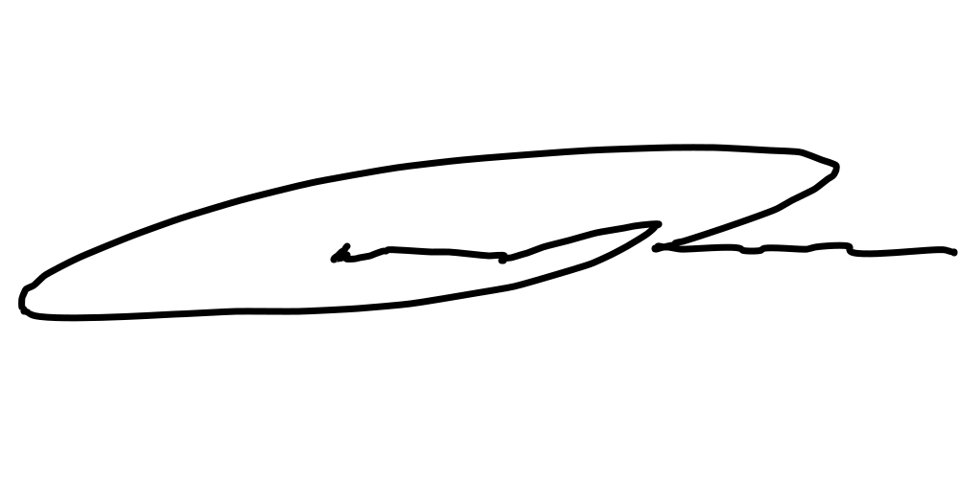
Manoah Camporini

